Creating a Codeless Machine Learning Model in PrediBot by predicting student studyHours :
Introduction:
PrediBot is a no-code machine learning platform that enables users to build, train, and deploy ML models without writing any programming code. It is designed for beginners, educators, and business professionals who want to explore predictive analytics quickly using Excel data or CSV files.
Basic needs: to create a model
Before creating your model, make sure you have:
- A PrediBot account (sign up at https://predibot.com or your institution’s portal).
- A dataset in .csv or .xlsx format.
Example: Student performance dataset, sales dataset, or employee salary data.
- A target variable (the column you want to predict, e.g., “Salary,” “Grade,” or “Profit”).

3. Steps to Create a Codeless ML Model

Step 1: Log in to PrediBot
- Open https://predibot.com.
- Log in with your credentials or sign up for a new account.
- Once logged in, navigate to the Dashboard.

Step 2: Upload Your Dataset
- Click on “Create New Project.”
- Select “Upload Data” and choose your dataset file (CSV or Excel).
- Wait for PrediBot to automatically detect the data types (numeric, categorical, etc.).
- Preview the dataset to ensure columns are correctly loaded.

Step 3: Select the Target Variable
- Identify the column you want to predict (for example, “Salary”).
- PrediBot will automatically classify the problem type:
  - Regression – if target is continuous (e.g., Salary, Profit).
  - Classification – if target is categorical (e.g., Pass/Fail, Yes/No).
- Step 4: Data Preprocessing
- PrediBot performs automatic data cleaning, including:
- Handling missing values.
- Converting categorical data into numerical form.
- Normalizing numeric features.
- Splitting data into training and testing sets.
- You can review and modify these settings if needed.

Step 5: Choose the ML Algorithm
PrediBot automatically recommends suitable algorithms (e.g., Decision Tree, Random Forest, Linear Regression, etc.) based on your data type.
You can:
- Let PrediBot auto-select the best model, or
- Manually choose one from the suggested options.

Step 6: Train the Model
- Click “Train Model.”
- PrediBot will process your dataset and build the model automatically.
- You can view progress and training metrics such as:
  - Accuracy
  - Precision, Recall, F1 Score (for classification)
  - R² and RMSE (for regression)
- Step 7: Evaluate the Model
- After training, PrediBot provides a detailed evaluation dashboard that includes:
- Confusion Matrix (for classification)
- Performance Graphs (training vs testing accuracy)
- Feature Importance – which variables most affect the prediction.
- You can use these insights to fine-tune the dataset or model settings.

Step 8: Make Predictions
- Go to the Prediction tab.
- Upload a new dataset (without the target column).
- Click “Predict.”
- PrediBot will generate predictions automatically and allow you to download the output file.

Step 9: Export and Share
- You can download the trained model, performance report, and predicted results.
- Reports can be exported in Excel, CSV, or PDF format.
- You can also share the model dashboard via a PrediBot link.

TAKING ONE EXAMPLE TO PREAPRE OUR OWN MODEL:
STEPS TO CREATE THE MODEL:
- Create one excel sheet by having data that is student details such as student Id , name , age , marks , performance , study hours.
- Now save the excel sheet into your desktop
- Open the predibot website and login into it
- Now click on choose files and upload the excel sheet in to it
- Now train the data to the machine
- Now enter seen data and unseen data
- Now apply the predict and get results

EXCEL SHEET :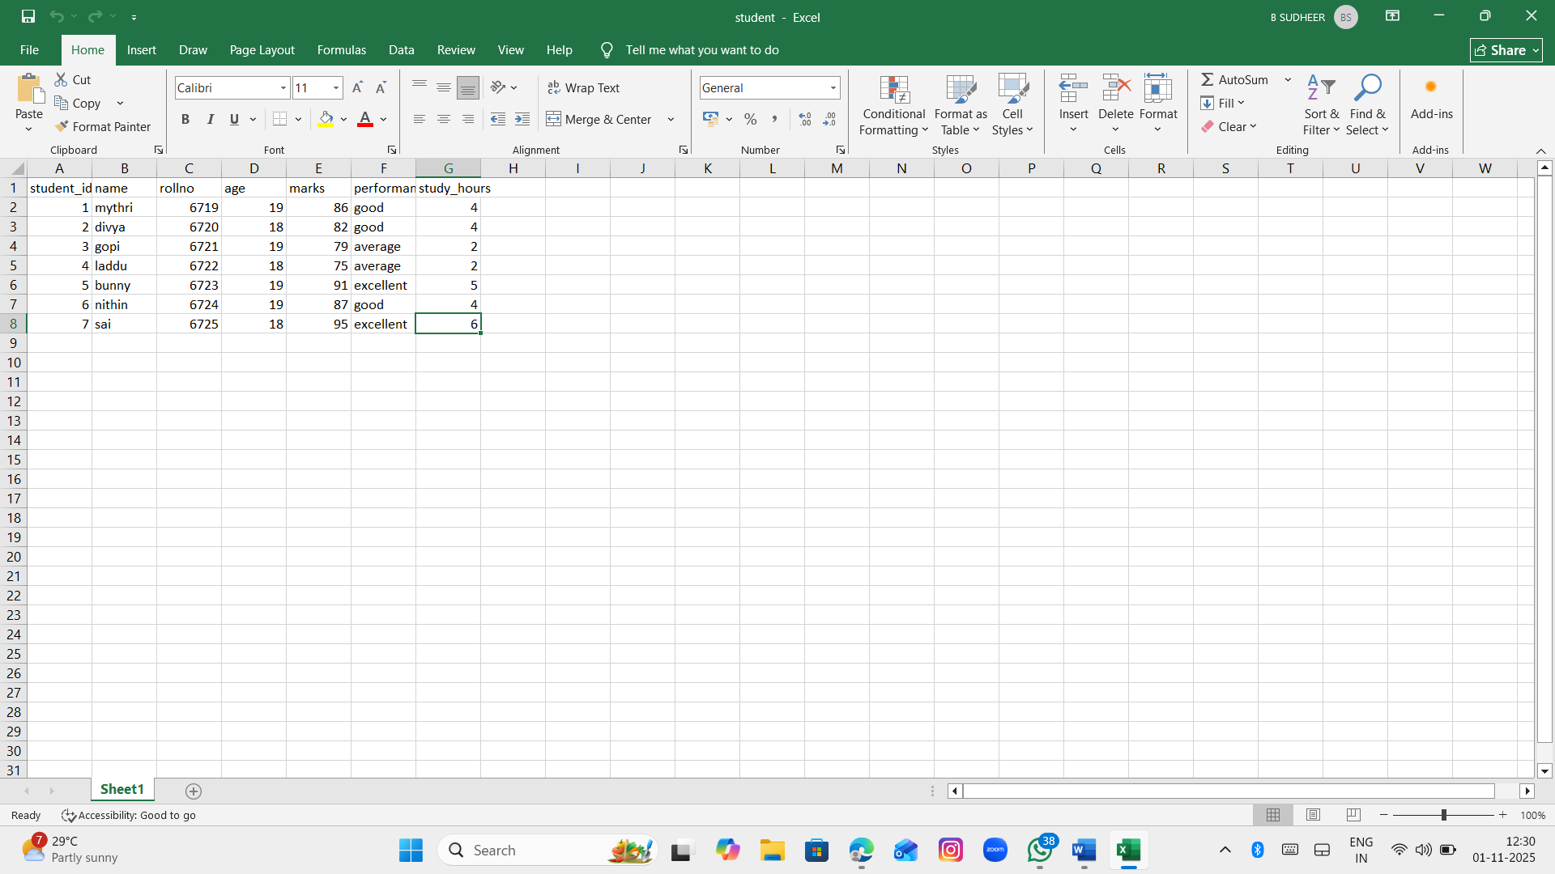
Output:
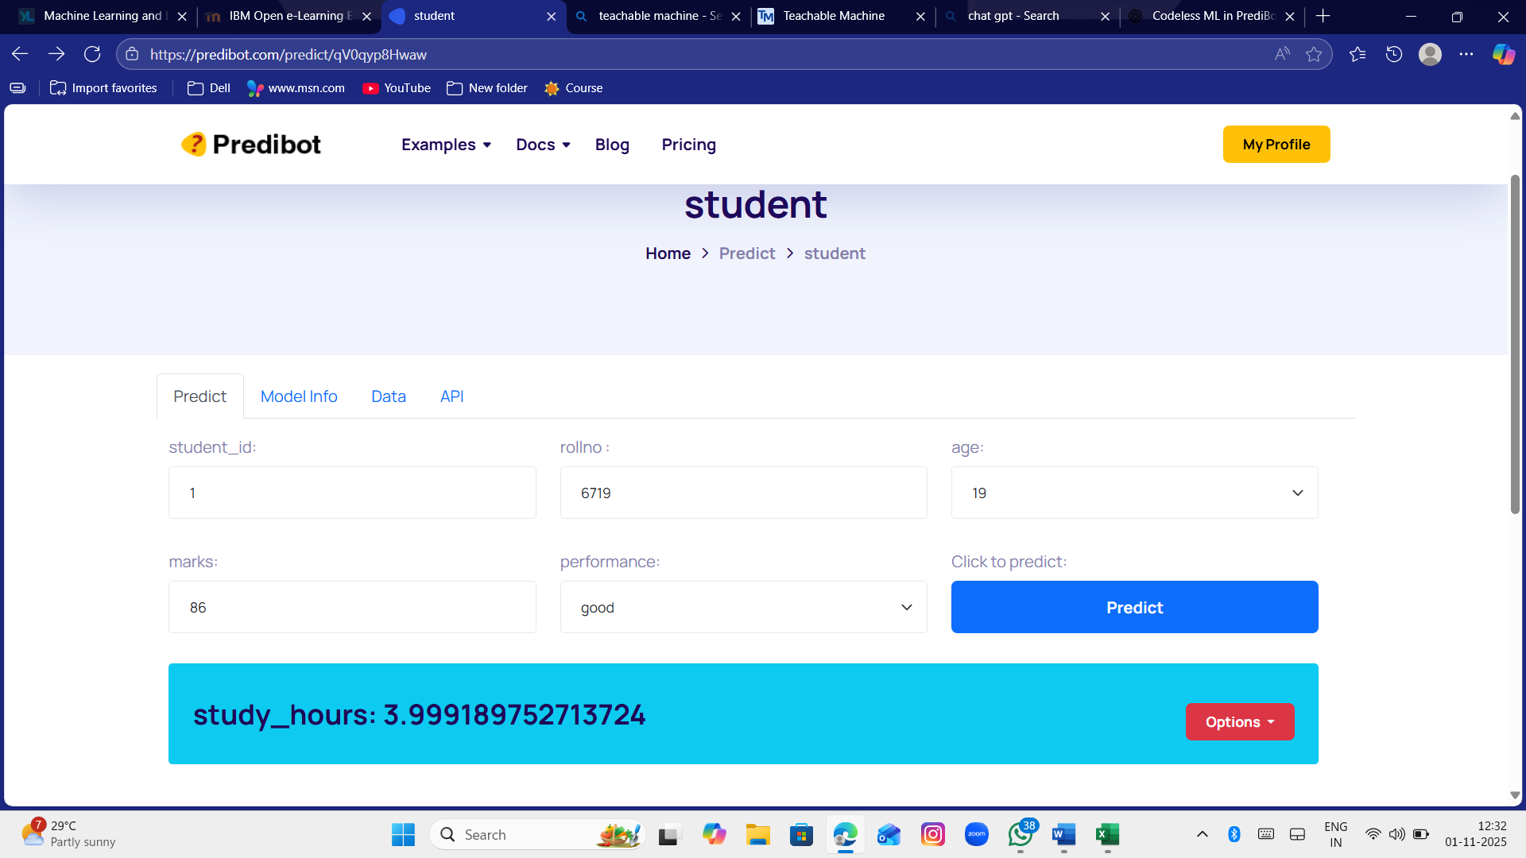

CONCLUSION:
PrediBot simplifies the entire machine learning workflow — from data upload to model deployment — without writing a single line of code.
By following the above steps, anyone can build a predictive model quickly, understand the results, and make data-driven decisions efficiently.

